Supporting information to:

Does specific parameterization of WHAM improve the prediction of copper competitive binding and toxicity on plant roots?

Authors:
Stéphanie Guigues^{1,2}, Matthieu N. Bravin^{3,*}, Cédric Garnier⁴ and Emmanuel Doelsch¹

Affiliations:
¹ CIRAD, UPR Recyclage et risque, F-34398 Montpellier, France
² ADEME, 20 avenue du Grésillé, BP-90406, Angers cedex 01, France
³ CIRAD, UPR Recyclage et risque, F-97408 Saint-Denis, Réunion, France
⁴ Université de Toulon, PROTEE, EA 3819, 83957 La Garde, France

* Corresponding author: matthieu.bravin@cirad.fr

Tables = 4
Figures = 5

Table S1
Initial (pM_{in}) and final/equilibrium (pM_{eq}) concentration of copper, calcium and zinc, pH and ionic strength (I) in the solutions of the five copper sorption experiments on wheat roots.
Exp. 1  Cu binding affinity | pCu_{in} | 7.3 |  |  | 7.3 |  | 7.3 |  | 7.3 |  | 7.3 |  | 7.3 |  | 7.3 |  | 7.3 |  | 7.3 |  | 7.2 |  |  | 7.2 |  |  |  |  | 7.1 |  | 7.1 |  | 7.0 |  | 7.0 |  | 6.8 |  | 6.8 |  | 6.7 |  | 6.7 | 6.4
 | pCu_{eq} | 8.0 |  |  | 8.1 |  | 8.1 |  | 8.1 |  | 8.0 |  | 8.0 |  | 8.0 |  | 7.9 |  | 7.9 |  | 7.8 |  |  | 7.7 |  |  |  |  | 7.8 |  | 7.7 |  | 7.6 |  | 7.5 |  | 7.4 |  | 7.3 |  | 7.1 |  | 7.1 | 6.9
 | pH | 5.0 |  |  | 4.9 |  | 4.9 |  | 4.9 |  | 4.9 |  | 4.7 |  | 4.9 |  | 4.9 |  | 4.7 |  | 4.9 |  |  | 4.9 |  |  |  |  | 4.9 |  | 4.8 |  | 4.9 |  | 4.9 |  | 4.9 |  | 4.9 |  | 4.9 |  | 4.9 | 4.9
 | I |  |  | Set at 30 mM
 | pCu_{in} | 6.4 |  |  | 6.2 |  | 6.2 |  | 6.0 |  | 6.0 |  | 5.7 |  | 5.7 |  | 5.5 |  | 5.5 |  | 5.2 |  |  | 5.2 |  |  |  |  | 5.0 |  | 5.0 |  | 4.7 |  | 4.7 |  | 4.5 |  | 4.5 |  | 4.2 |  | 4.2 | 4.0
 | pCu_{eq} | 6.9 |  |  | 6.6 |  | 6.6 |  | 6.3 |  | 6.3 |  | 6.0 |  | 6.1 |  | 5.8 |  | 5.8 |  | 5.5 |  |  | 5.5 |  |  |  |  | 5.2 |  | 5.2 |  | 4.9 |  | 4.9 |  | 4.6 |  | 4.6 |  | 4.3 |  | 4.4 | 4.1
 | pH | 4.9 |  |  | 4.9 |  | 4.9 |  | 4.9 |  | 4.8 |  | 4.7 |  | 4.9 |  | 4.8 |  | 4.8 |  | 4.8 |  |  | 4.9 |  |  |  |  | 4.8 |  | 4.8 |  | 4.8 |  | 4.8 |  | 4.8 |  | 4.7 |  | 4.8 |  | 4.8 | 4.8
 | I |  |  | Set at 30 mM
Exp. 2  Effect of ionic strength | pCu_{in} | 7.0 | 7.0 |  |  | 7.0 |  | 6.2 |  | 6.2 |  | 5.2 |  | 5.2 |  | 5.2 |  | 4.2 |  | 7.0 |  |  | 7.0 |  | 7.0 |  |  | 6.2 |  | 6.2 |  | 6.2 |  | 5.2 |  | 5.2 |  | 5.2
 | pCu_{eq} | 7.1 | 7.1 |  |  | 7.1 |  | 6.5 |  | 6.5 |  | 5.4 |  | 5.4 |  | 5.4 |  | 4.4 |  | 7.5 |  |  | 7.6 |  | 7.5 |  |  | 6.9 |  | 6.8 |  | 6.9 |  | 5.5 |  | 5.5 |  | 5.5
 | pH | 4.8 | 4.8 |  |  | 4.8 |  | 4.8 |  | 4.9 |  | 4.8 |  | 4.9 |  | 5.0 |  | 4.8 |  | 4.7 |  |  | 4.8 |  | 4.8 |  |  | 4.8 |  | 4.7 |  | ∕ |  | 4.8 |  | 4.7 |  | 4.8
 | I | Set at 300 mM |  |  |  |  |  |  |  |  |  |  |  |  |  |  |  |  |  |  |  | Set at 0.6 mM
Exp. 3  Proton competition | pCu_{in} | 7.0 | 7.0 |  |  | 7.0 |  | 6.2 |  | 6.2 |  | 6.2 |  | 5.2 |  | 5.2 |  | 5.2 |  | 7.0 |  |  | 7.0 |  | 7.0 |  |  | 6.2 |  | 6.2 |  | 6.2 |  | 5.2 |  | 5.2
 | pCu_{eq} | 7.3 | 7.3 |  |  | 7.3 |  | 6.4 |  | 6.4 |  | 6.5 |  | 5.3 |  | 5.4 |  | 5.3 |  | 7.4 |  |  | 7.3 |  | 7.4 |  |  | 6.7 |  | 6.8 |  | 6.7 |  | 5.7 |  | 5.8
 | pH | 4.0 | 4.0 |  |  | 4.0 |  | 4.0 |  | 4.0 |  | 4.0 |  | 4.0 |  | 4.0 |  | 4.0 |  | 6.3 |  |  | 6.4 |  | 6.3 |  |  | 6.4 |  | 6.3 |  | 6.3 |  | 6.3 |  | 6.3
 | I | Set at 30 mM |  |  |  |  |  |  |  |  |  |  |  |  |  |  |  |  |  |  |  | Set at 30 mM
Exp. 4 and 5  Ca and Zn competition | pCu_{in} | Ca |  |  | 6.2 |  | 6.2 |  | 6.2 |  | 6.2 |  | 6.2 |  | 6.2 |  | 6.2 |  | 6.2 |  | 6.2 |  |  | 6.2 |  |  |  |  | Zn |  | 6.2 |  | 6.2 |  | 6.2 |  | 6.2 |  | 6.2 |  | 6.2 |  | 6.2
 | pCu_{eq} |  |  |  | 6.6 |  | 6.6 |  | 6.6 |  | 6.6 |  | 6.6 |  | 6.6 |  | 6.5 |  | 6.6 |  | 6.5 |  |  | 6.6 |  |  |  |  |  |  | 6.7 |  | 6.7 |  | 6.7 |  | 6.6 |  | 6.5 |  | 6.4 |  | 6.5
 | pM_{in} |  |  |  | 4.0 |  | 4.0 |  | 3.5 |  | 3.5 |  | 3.0 |  | 3.0 |  | 2.5 |  | 2.5 |  | 2.0 |  |  | 2.0 |  |  |  |  |  |  | 7.2 |  | 6.0 |  | 6.0 |  | 5.2 |  | 5.2 |  | 4.5 |  | 4.5
 | pM_{eq} |  |  |  | 4.7 |  | 4.7 |  | 4.2 |  | 4.2 |  | 3.7 |  | 3.7 |  | 3.1 |  | 3.1 |  | 2.2 |  |  | 2.3 |  |  |  |  |  |  | 7.2 |  | 6.0 |  | 6.0 |  | 6.0 |  | 6.0 |  | 4.6 |  | 4.6
 | pH |  |  |  | 4.9 |  | 4.9 |  | 4.8 |  | 4.9 |  | 4.9 |  | 4.9 |  | 4.8 |  | 4.8 |  | 4.6 |  |  | 4.8 |  |  |  |  |  |  | 4.8 |  | 4.9 |  | 4.9 |  | 4.9 |  | 4.9 |  | 4.8 |  | 4.9
 | I |  |  |  | Set at 30 mM |  |  |  |  |  |  |  |  |  |  |  |  |  |  |  |  |  |  |  |  |  |  |  |  |  | Set at 30 mM

Table S2
Initial (pM_{in}) and final/equilibrium (pM_{eq}) concentration of copper, calcium and zinc, pH and ionic strength (I) in the solutions of the five copper sorption experiments on tomato roots.
Exp. 1  Cu binding affinity | pCu_{in} | 7.3 |  | 7.3 |  | 7.3 |  | 7.3 |  | 7.2 |  | 7.2 |  | 7.2 |  | 7.2 |  | 7.2 |  | 7.2 |  |  | 7.1 |  | 7.1 |  | 7.1 |  | 7.1 |  | 7.0 |  | 7.0 | 6.8 | 6.8 | 6.6 | 6.6
 | pCu_{eq} | 8.0 |  | 8.1 |  | 8.1 |  | 8.0 |  | 8.0 |  | 8.0 |  | 8.0 |  | 7.9 |  | 8.0 |  | 7.9 |  |  | 7.8 |  | 7.8 |  | 7.8 |  | 7.8 |  | 7.6 |  | 7.7 | 7.5 | 7.6 | 7.3 | 7.4
 | pH | 4.5 |  | 4.6 |  | 4.6 |  | 4.7 |  | 4.6 |  | 4.6 |  | 4.6 |  | 4.6 |  | 4.6 |  | 4.6 |  |  | 4.6 |  | 4.6 |  | 4.6 |  | 4.5 |  | 4.5 |  | 4.5 | 4.6 | 4.6 | 4.6 | 4.6
 | I | Set at 30 mM
 | pCu_{in} | 6.4 |  | 6.4 |  | 6.2 |  | 6.2 |  | 6.0 |  | 6.0 |  | 5.7 |  | 5.7 |  | 5.5 |  | 5.5 |  |  | 5.2 |  | 5.2 |  | 5.0 |  | 5.0 |  | 4.7 |  | 4.7 | 4.5 | 4.5 | 4.2 | 4.2
 | pCu_{eq} | 7.2 |  | 7.1 |  | 7.1 |  | 7.1 |  | 6.7 |  | 6.8 |  | 6.5 |  | 6.5 |  | 6.1 |  | 6.2 |  |  | 5.9 |  | 5.9 |  | 5.7 |  | 5.6 |  | 5.3 |  | 5.4 | 5.1 | 5.0 | 4.8 | 4.8
 | pH | 4.6 |  | 4.6 |  | 4.5 |  | 4.5 |  | 4.6 |  | 4.5 |  | 4.5 |  | 4.6 |  | 4.6 |  | 4.6 |  |  | 4.5 |  | 4.5 |  | 4.5 |  | 4.6 |  | 4.6 |  | 4.5 | 4.5 | 4.5 | 4.6 | 4.5
 | I | Set at 30 mM
 | pCu_{in} | 4.0 |  | 4.0 |  | 3.6 |  | 3.6 |  | 3.3 |  | 3.3 |  | 3.0 |  | 3.0
 | pCu_{eq} | 4.5 |  | 4.5 |  | 3.8 |  | 3.8 |  | 3.5 |  | 3.5 |  | 3.1 |  | 3.2
 | pH | 4.4 |  | 4.4 |  | 4.7 |  | 4.6 |  | 4.2 |  | 4.4 |  | 4.3 |  | 4.1
 | I | Set at 30 mM
Exp. 2  Effect of ionic strength | pCu_{in} | 6.2 | 6.2 |  | 5.2 |  | 5.2 |  | 4.2 |  | 4.2 |  | 6.2 |  | 6.2 |  | 5.2 |  | 5.2 |  | 4.2 | 4.2
 | pCu_{eq} | 6.6 | 6.4 |  | 5.6 |  | 5.5 |  | 4.4 |  | 4.6 |  | 7.4 |  | 7.3 |  | 6.3 |  | 6.3 |  | 4.9 | 4.9
 | pH | 5.0 | 5.0 |  | 4.9 |  | 4.9 |  | 4.8 |  | 4.8 |  | 4.5 |  | 4.6 |  | 4.6 |  | 4.3 |  | 4.2 | 4.2
 | I | Set at 300 mM |  |  |  |  |  |  |  |  |  |  | Set at 0.6 mM
Exp. 3  Proton competition | pCu_{in} | 6.2 | 6.2 |  | 5.2 |  | 5.2 |  | 4.2 |  | 4.2 |  | 6.2 |  | 6.2 |  | 5.2 |  | 5.2 |  | 4.2 | 4.2
 | pCu_{eq} | 6.9 | 6.9 |  | 5.7 |  | 5.8 |  | 4.6 |  | 4.4 |  | 6.8 |  | 6.9 |  | 6.0 |  | 5.9 |  | 4.7 | 4.7
 | pH | 4.2 | 4.2 |  | 4.2 |  | 4.2 |  | 4.1 |  | 4.1 |  | 6.3 |  | 6.2 |  | 6.2 |  | 6.3 |  | 6.1 | 6.2
 | I | Set at 30 mM |  |  |  |  |  |  |  |  |  |  | Set at 30 mM
Exp. 4 and 5  Ca and Zn competition | pCu_{in} | Ca |  | 6.2 |  | 6.2 |  | 6.2 |  | 6.2 |  | 6.2 |  | 6.2 |  | 6.2 |  | 6.2 |  | 6.2 |  |  | 6.2 |  | Zn |  | 6.2 |  | 6.2 |  | 6.2 |  | 6.2 | 6.2 | 6.2 | 6.2 | 6.2
 | pCu_{eq} |  |  | 6.8 |  | 6.8 |  | 6.8 |  | 7.1 |  | 7.2 |  | 6.9 |  | 6.9 |  | 6.8 |  | 6.7 |  |  | 6.9 |  |  |  | 7.0 |  | 7.0 |  | 6.9 |  | 7.0 | 6.9 | 6.7 | 6.7 | 6.7
 | pM_{in} |  |  | 3.9 |  | 3.9 |  | 3.5 |  | 3.5 |  | 3.0 |  | 3.0 |  | 2.5 |  | 2.5 |  | 2.0 |  |  | 2.0 |  |  |  | 6.9 |  | 6.6 |  | 6.0 |  | 5.2 | 5.2 | 5.2 | 4.5 | 4.5
 | pM_{eq} |  |  | 3.9 |  | 4.0 |  | 4.1 |  | 4.0 |  | 3.4 |  | 3.4 |  | 2.8 |  | 2.8 |  | 2.2 |  |  | 2.2 |  |  |  | 7.1 |  | 6.9 |  | 6.4 |  | 5.6 | 5.6 | 5.6 | 4.9 | 5.0
 | pH |  |  | 5.2 |  | 4.9 |  | 4.7 |  | 4.6 |  | 5.5 |  | 5.6 |  | 5.5 |  | 5.8 |  | 5.6 |  |  | 5.7 |  |  |  | 4.7 |  | 4.7 |  | 4.6 |  | 4.6 | 4.6 | 4.6 | 4.5 | 4.7
 | I |  |  | Set at 30 mM |  |  |  |  |  |  |  |  |  |  |  |  |  |  |  |  |  |  |  |  |  |  | Set at 30 mM

Table S3
Literature review of ratios between the density of low-pKa (pKa < 7.5) and high-pKa (pKa ≥ 7.5) sites (L/H ratios) measured on the roots of terrestrial higher plants.
Group | Species¹ | Plant age (days) | L/H  ratio | Reference
Dicots | Pisum sativum L. | 10 | 1.7 | Wu and Hendershot 2009
 |  | 35 | 0.5 | Meychik and Yermakov 1999 and 2001
 | Solanum lycopersicum L. | 21 | 0.9 | Guigues et al. 2014
 |  | 21 | 1.1 | Unpublished data²
 | White Lupin L. | 10 | 3.8 | Meychik and Yermakov 1999 and 2001
Monocots | Festuca rubra L. | 30 | 1.4 | Ginn et al. 2008
 | Lolium perenne L. | 21 | 2.9 | Unpublished data
 | Triticum aestivum L. | 10 | 0.4 | Meychik and Yermakov 1999 and 2001
 |  | 21 | 0.5 | Guigues et al. 2014
 |  | 38 | 0.4 | Meychik and Yermakov 1999 and 2001
¹ All plant species were grown in hydroponic conditions except for F. rubra, which was grown in pots using commercially supplied potting soil.
² Plants corresponding to the sitiens mutant of the wild-type Moneymaker cultivar of S. lycopersicum (see Curvers et al. 2010 for further information)

Table S4
Root mean square error ª (RMSE) between measured and modelled data of potentiometric titrations and copper (Cu) sorption experiments (see Table S1 and S2 and section 2.3) for wheat and tomato roots. Modelled data were obtained with the Windermere Humic Aqueous Model parameterized by default (WHAM) or specifically parameterized with two humic acids for terrestrial higher plants (WHAM-THP). RMSE was calculated from untransformed data for potentiometric titrations as some experimental data were negative. RMSE was calculated from log₁₀-transformed data for Cu sorption experiments to balance the weight of the highest values.
 |  | n ^{b} | WHAM | WHAM-THP
Potentiometric titrations (cmol_{c}.kg⁻¹) | Wheat | 65 | 9.0 | 1.0
 | Tomato | 111 | 14.4 | 1.8
Cu sorption exp. 1: Cu binding affinity | Wheat | 40 | 0.23 | 0.04
 | Tomato ^{c} | 48 | 0.14 | 0.14
Cu sorption exp. 2: Effect of ionic strength | Wheat | 19 | 0.38 | 0.21
 | Tomato | 12 | 0.18 | 0.11
Cu sorption exp. 3: Proton competition | Wheat | 17 | 0.35 | 0.31
 | Tomato | 12 | 0.14 | 0.17
Cu sorption exp. 4 and 5: Ca and Zn competition | Wheat | 17 | 0.28 | 0.04
 | Tomato | 18 | 0.12 | 0.03
ª $RMSE= \sqrt{\frac{\sum_{i=1}^{n}{{(x_{i,exp}-x_{i, model})}^{2}}}{n}}$ where $x_{i,exp}$ is an experimental datum, $x_{i, model}$ its corresponding modelled datum and n the number of experimental data
^{b} Number of experimental data
^{c} When removing experimental data for pCu_{in} ≤ 4.5, RMSE for Cu binding on tomato roots were equal to 0.09 and 0.03 for WHAM and WHAM-THP, respectively (see section 4.2.1 for rationale).

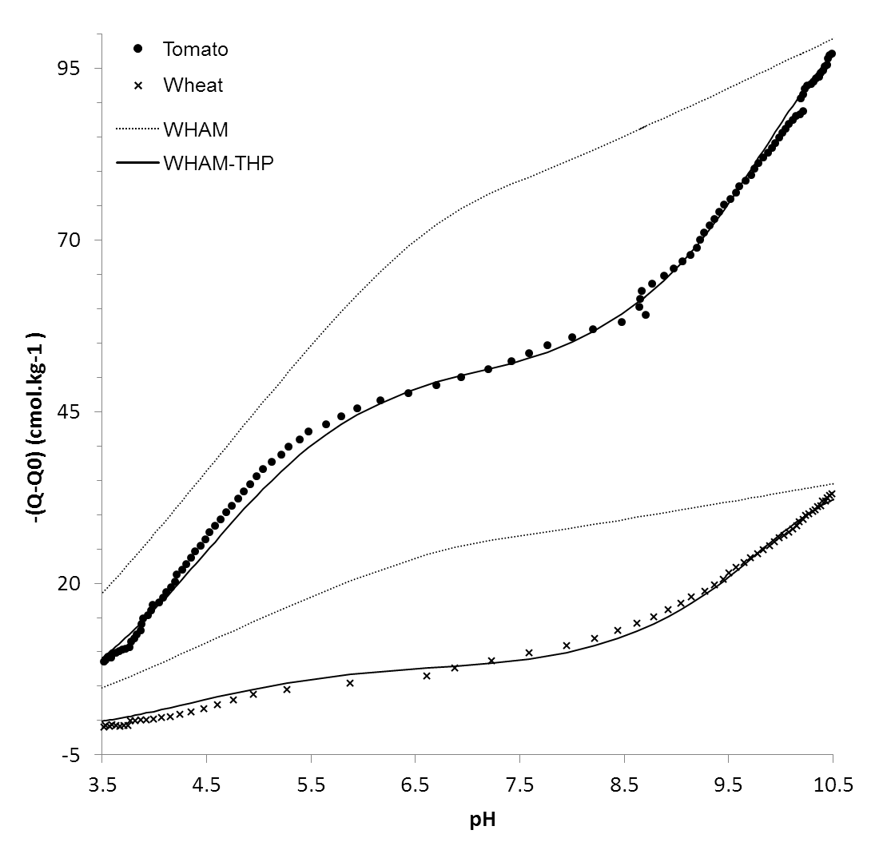

Figure S1 Potentiometric titration of wheat (crosses) and tomato (circles) roots expressed in charge (Q) corrected by the initial charge (Q0). Dotted and solid lines correspond to simulations performed with the Windermere Humic Aqueous Model parameterized by default (WHAM) and specifically parameterized with two humic acids for terrestrial higher plants (WHAM-THP), respectively.

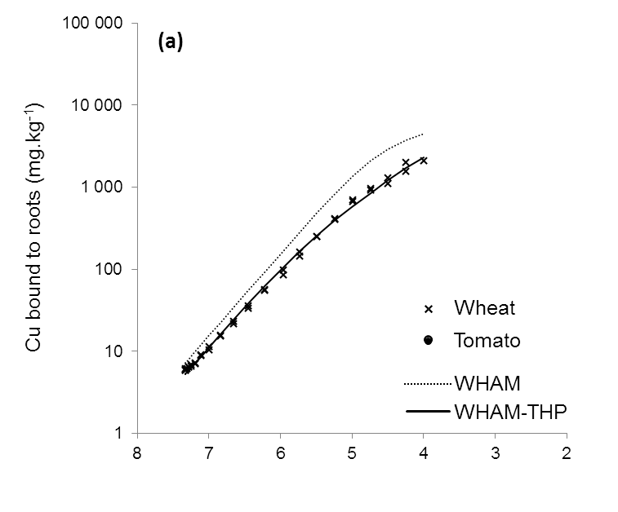
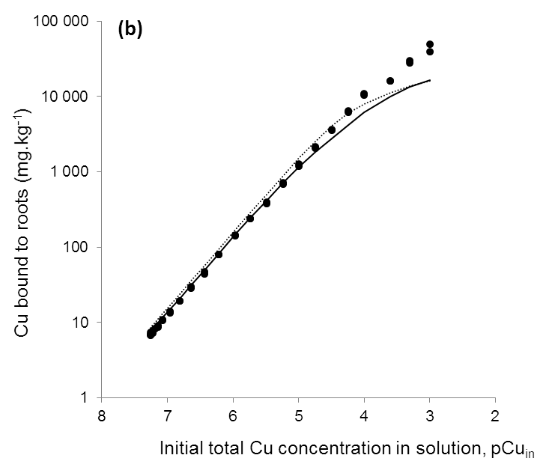

Figure S2 Copper binding on wheat (crosses, a) and tomato (circles, b) roots at pH 4.7 (± 0.2) and an ionic strength of 0.03 M. Dotted and solid lines correspond to simulations performed with the Windermere Humic Aqueous Model parameterized by default (WHAM) and specifically parameterized with two humic acids for terrestrial higher plants (WHAM-THP), respectively.

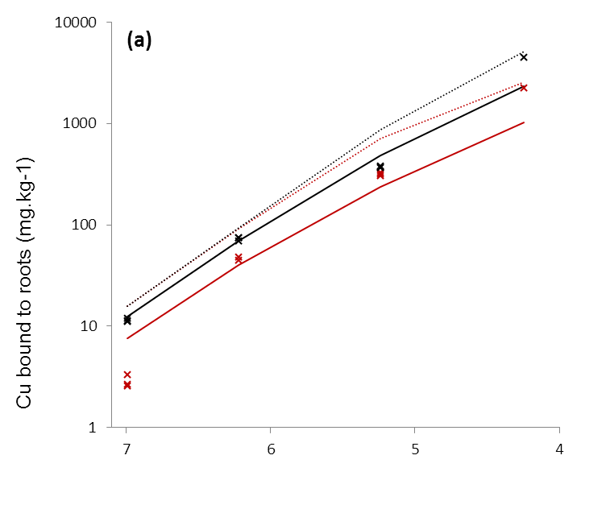
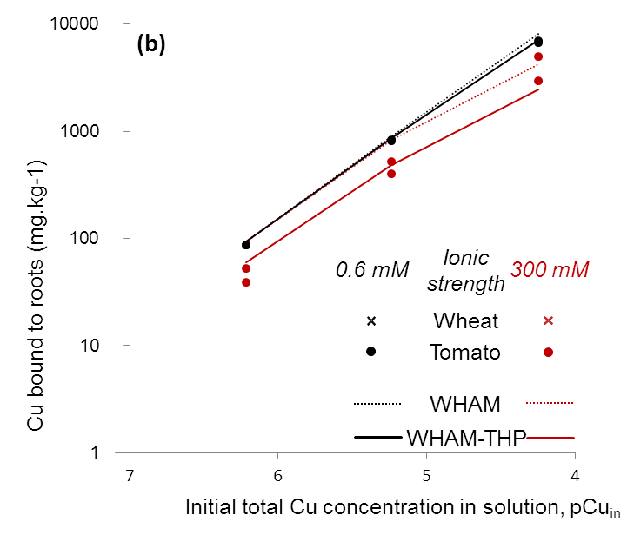

Figure S3 Copper binding on wheat (crosses, a) and tomato (circles, b) roots at an ionic strength of 0.6 mM (dark symbols and lines) or 300 mM (red symbols and lines) and at pH 4.7 (± 0.2). Dotted and solid lines correspond to simulations performed with the Windermere Humic Aqueous Model parameterized by default (WHAM) and specifically parameterized with two humic acids for terrestrial higher plants (WHAM-THP), respectively.

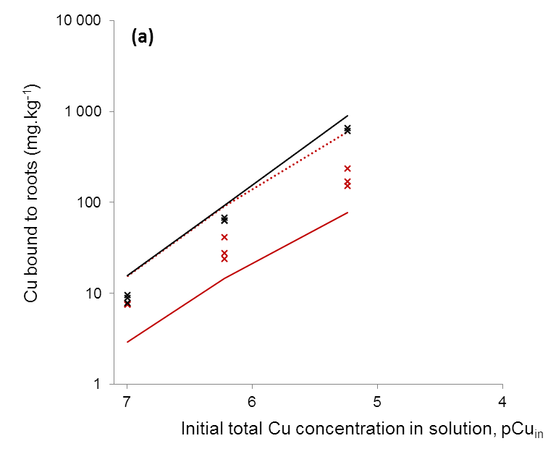
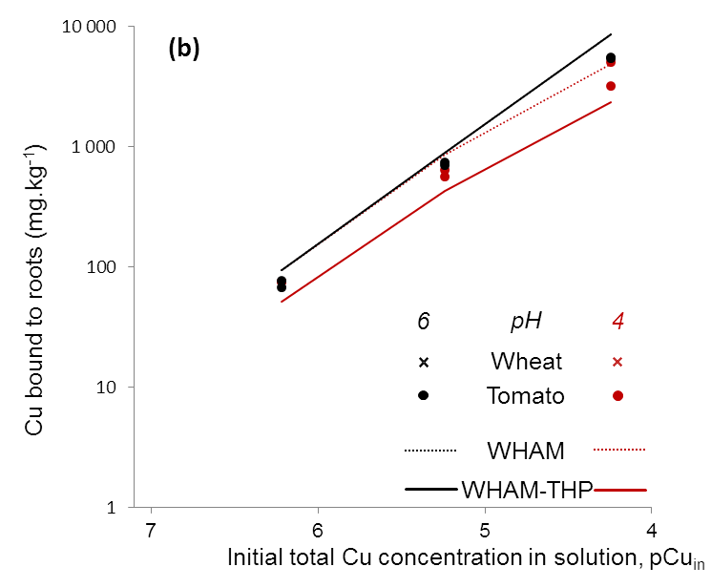

Figure S4 Copper binding on wheat (crosses, a) and tomato (circles, b) roots at pH 6.3 (± 0.1) (dark symbols and lines) and pH 4.1 (± 0.1) (red symbols and lines) with an ionic strength of 0.03 M. Dotted and solid lines correspond to simulations performed with the Windermere Humic Aqueous Model parameterized by default (WHAM) and specifically parameterized with two humic acids for terrestrial higher plants (WHAM-THP), respectively.

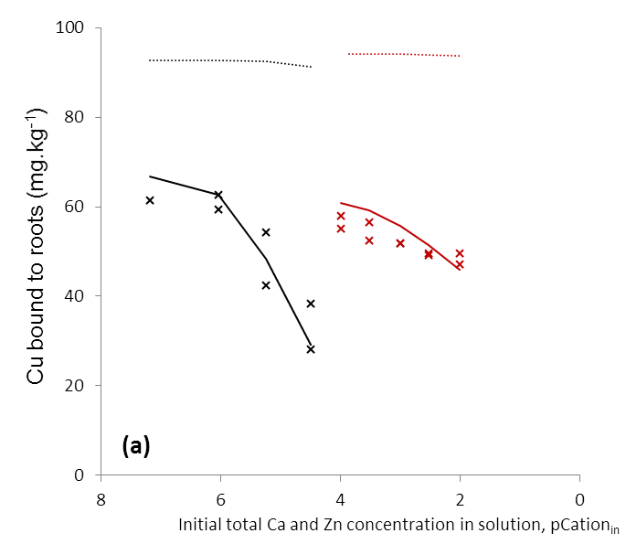
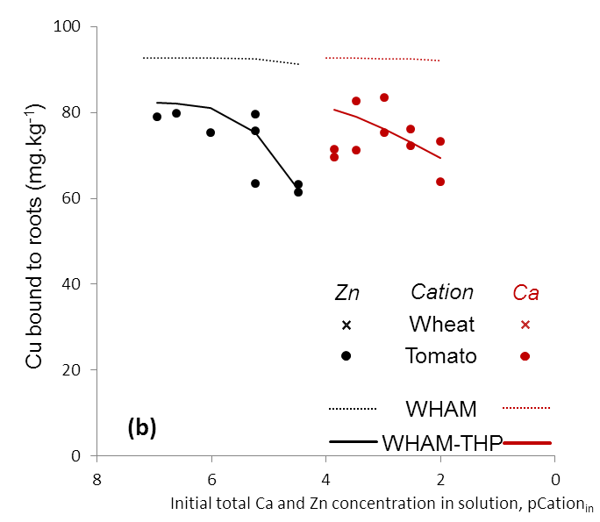

Figure S5 Copper binding on wheat (crosses, a) and tomato (circles, b) roots in the presence of Ca (red symbols and lines) and Zn (dark symbols and lines) at an ionic strength of 0.03 M and pH 4.9 (± 0.3). Dotted and solid lines correspond to simulations performed with the Windermere Humic Aqueous Model parameterized by default (WHAM) and specifically parameterized with two humic acids for terrestrial higher plants (WHAM-THP), respectively.

References

Curvers K, Seifi H, Mouille G, de Rycke R, Asselbergh B, Van Hecke A, Vanderschaeghe D, Höfte H, Callewaert N, Van Breusegen F, Höfte M (2010) Abscisic acid deficiency causes changes in cuticle permeability and pectin composition that influence tomato resistance to Botrytis cinerea. Plant Physiology 154:847-860.
Ginn BR, Szymanowski JS, Fein JB (2008) Metal and proton binding onto the roots of Fescue rubra. Chemical Geology 253 (3-4):130-135. doi:10.1016/j.chemgeo.2008.05.001
Guigues S, Bravin MN, Garnier C, Masion A, Doelsch E (2014) Isolated cell walls exhibit cation binding properties distinct from those of plant roots. Plant and Soil:1-13. doi:10.1007/s11104-014-2138-1
Meychik NR, Yermakov IP (1999) A new approach to the investigation on the tonogenic groups of root cell walls. Plant Soil 217:257-264.
Meychik NR, Yermakov IP (2001) Ion exchange properties of plant root cell walls. Plant Soil 234:181-193.
Wu Y, Hendershot W (2009) Cation Exchange Capacity and Proton Binding Properties of Pea (Pisum sativum L.) Roots. Water, Air, Soil Pollution 200 (1):353-369. doi:10.1007/s11270-008-9918-2

