Supplementary Material 1

Origin and Dispersal of Domesticated Peach Palm
Charles R. Clement*, Michelly de Cristo-Araújo, Geo Coppens d’Eeckenbrugge, Vanessa Maciel dos Reis, Romain Lehnebach, Doriane Picanço-Rodrigues
* Correspondence: Corresponding Author: cclement@inpa.gov.br

Supplementary Text
1.1 Dispersal of the incipient domesticate
There are only two accessions of var. chichagui type 1 and two of the incipient domesticate (var. chichagui type 3) in the Core Collection used in this genetic analysis. Hence, almost nothing is known about the distribution of the psbJ-petA inversion in the area of sympatry with type 1, although both type 3 accessions from the Ucayali River contain the inversion and the type 1 population near Rio Branco, Acre is polymorphic for the inversion. No type 3 plants have ever been reported from the eastern dispersal of var. gasipaes, except in the upper Madeira River basin (Saldías-Paz, 1993; Clement et al., 2009b), so type 3 does not appear to be a simple segregant from other domesticated populations. The outline of the dispersal of the incipient domesticate from southwestern Amazonia into western Amazonia and over the Andes into western Ecuador and Colombia, and on into Central America that follows is based on herbarium records, collecting reports and the literature.
Based on the observations of Saldías-Paz (1993) and the chloroplast sequence, lowland Bolivia is the location of the origin of domestication and consequently the origin of what is probably the first dispersal: the disjunct distribution of var. chichagui type 3 (Figure 1). D’Orbigny’s collection of Guilielma insignis (described by Martius) probably represents the incipient domesticate or possibly a small microcarpa population of var. gasipaes. Although d’Orbigny (1847) did not give fruit sizes, he did observe situations similar to Saldías-Paz: “Sans être très-commune, elle n’est pas rare, surtout près des lieux habités, où l’on cherche à la multiplier, vu son utilité.” [Without being very common, it is not rare, especially close to inhabited places, where one seeks to multiply it, given its utility. Authors’ translation]. Samples of type 3 have been observed along the Ucayali River, first by Huber (1904), and even earlier in its western tributaries in the Andean foothills by Ruiz and Pavón (1798), who apparently collected both types 1 and 3 without making a distinction (Henderson, 2000). The expeditions that collected the accessions in the Core Collection found it in Pucallpa and Contamana (Clement and Coradin, 1988).
The region between the lower Ucayali River and the collections of var. chichagui in eastern Ecuador reported by Borchsenius et al. (1998) (originally identified as B. macana because of Henderson’s (1995) preliminary ideas for the 2000 revision) is the major disjunction in type 3’s distribution, and may be a collection artifact because of the paucity of Bactris collections in that region. Couvreur et al. (2006) included the western Ecuadorian type 3 in their analysis that identified introgression between var. chichagui and cultivated peach palm. The Chocó biogeographic region also contains populations of var. chichagui (Pintaud et al., 2008), almost certainly type 3 given the lack of adaptation of type 2 in this super-humid region (Figure 3). The collection locality of B. speciosa var. chichaqui (H. Karsten) is in the upper Cauca and Magdalena River valleys of western Colombia, but no collections have been made in the valleys of the eastern Andes in Colombia. Arroyo and Mora-Urpí (1996) reported a population with very small fruit near the Cuchunaque River, in Darién, southeastern Panamá, a population with small fruit on the Azuero peninsula in southwestern Panamá, and another in the vicinity of Upala in northern Costa Rica. These northern populations of var. chichagui type 3 are not far from the archaeological sites with the oldest dates of carbonized seeds (between 2300 and 1700 BP) (Corrales-Ulloa and Mora-Urpí, 1990; Morcote-Rios and Bernal, 2001). Corrales-Ulloa and Mora-Urpí propose that the fruit probably weighed about 17 g, which represents a small microcarpa population of var. gasipaes, a priori suggesting in situ development of the Utilis landrace (but see below).
The archaeological dates in Costa Rica are rather recent, compared to Clement’s (1988) hypothesis that domestication started in the early Holocene (see also Clement et al. (2009a)). However, an early dispersal fits with the presence of populations of type 3 that do not appear to be simple segregants in otherwise domesticated populations, e.g., in western Ecuador where numerous plants have been observed along transects, with some introgression with cultivated populations (Couvreur et al., 2006). Hernández-Ugalde et al. (2011) observed that the Azuero type 3 population was somewhat different from their Tuira and Utilis samples, and did not group at the base of that branch of their dendrogram, suggesting introgression rather than in situ development of the Utilis landrace. Also, Clement et al. (2010) identified a trend among Amazonian domesticates: those with the widest dispersals and most complex population structures were domesticated earliest, i.e., manioc (Manihot esculenta) and Capsicum peppers, both with very early archaeological dates from sites along the Pacific coast of Peru without being endemic there (Pearsall, 1992). Although no early dates have been reported for peach palm, it is widely dispersed and has a landrace complex that has been genetically validated (Rodrigues et al., 2005; Cristo-Araújo et al., 2010).
Transforming this information about the distribution of type 3 into a record of dispersal requires a new effort to analyze existing samples of type 3 with appropriate molecular markers to examine the geographic distribution of its genetic diversity. This will also determine whether each landrace along the route was developed in situ, as was observed with Spondias purpurea in Mexico and Central America (Miller and Schaal, 2005) and suggested for peach palm by Mora-Urpí (1999) and Hernández-Ugalde et al. (2011), or dispersed later on, as observed with Inga edulis in western Amazonia (Hollingsworth et al., 2005; Dawson et al., 2008). The latter trend is certain for the peach palm landraces that are not sympatric with type 3, such as the macrocarpa Vaupés and mesocarpa Inirida landraces in eastern Colombia (Figure 1) and certainly other landraces in other parts of northern South America east of the Andes that remain to be described.
1.2 Ecological niche models of var. chichagui type 3 and var. gasipaes
To develop the ecological niche models, we needed to access information from international databases (see Supplementary Material 2), because the Peach palm Active Germplasm Bank at INPA is not representative of peach palm across its Neotropical distribution (Figure S1). In fact, no Latin American peach palm germplasm bank is representative, including the once large bank in Costa Rica. This is a major reason that a Core Collection was created within the germplasm bank (Cristo-Araújo et al., 2015). The reason that germplasm banks tend not to be representative is that most collecting is opportunistic and done with limited resources. Even the US Agency for International Development prospections across the Amazon basin in 1982-1983 (Clement and Coradin, 1988) collected only along major rivers and near cities with airports. This is true of most biological research in Amazonia (Hopkins, 2007; Feeley, 2015).
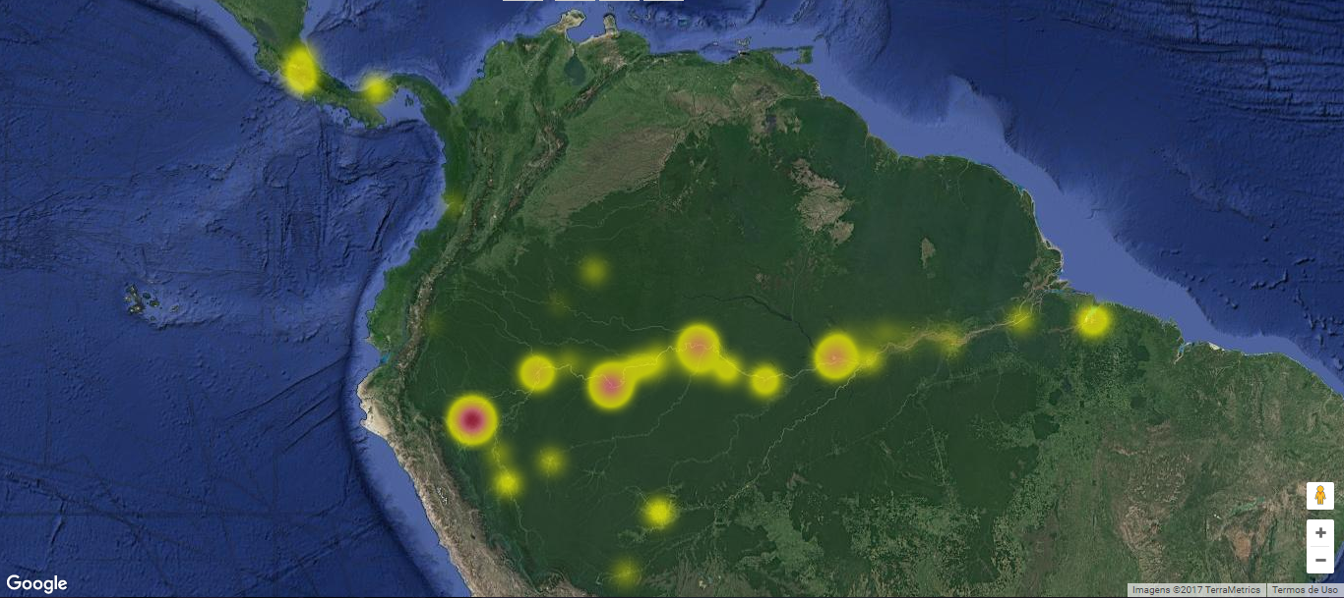
Figure S1. Heat map of the geographic distribution of 372 accessions of Bactris gasipaes var. gasipaes and var. chichagui currently maintained in the Peach Palm Active Germplasm Bank at the Instituto Nacional de Pesquisas da Amazônia, Manaus, Amazonas, Brazil. Map created by Raquel S. Chaves using <http://alelobag.cenargen.embrapa.br/AleloConsultas/Passaporte/mapa.do> managed by Embrapa Recursos Genéticos e Biotecnologia, Brasília, on 22 February 2017.
There are two things that explain our modest sample size: 1) “Because of their spines, specimens of Bactris are seldom collected and herbarium specimens are consequently few.” (Henderson, 2000; p.2); and 2) the history of taxonomic nomenclature in Bactris complicates identification to type. The first reason helps explain why there are so few herbarium specimens in regions where ethnography and anecdote report peach palm, even cultivated. The second reason means that most recently collected var. chichagui specimens cannot be used without recourse to the botanist who collected them, and even then identification to type may be uncertain unless the botanist is very familiar with Bactris and its historical nomenclature. This is how we were able to expand type 2’s sample size and distribution along the eastern flank of the Colombian Andes: assistance from Dr. Rodrigo Bernal, Universidad Nacional de Colombia. A similar exercise should be done to expand collecting in the Colombian Guajira department and in the Venezuelan states of Barinas, Portuguesa and Lara. There, according to our model, slightly drier and more contrasted climatic conditions are also favorable for var. chichagui, although not a single sample has been collected to date.
The number of field collections and herbarium samples that could reasonably be attributed to var. chichagui type 3 is quite small (n = 29). See Supplementary Material 2 for complete records. With such a small number, the ecological niche model is consequently less reliable (Figure S2A). Because this is the incipient domesticate, it was not possible to combine with var. chichagui types 1 and 2 to obtain better precision, as explained in the main text. Nonetheless, the model suggests that type 3’s climatic envelop is slightly more humid than that of type 1, based on the expansion from Southwestern Amazonia northwards (compare with Figure 2B).
Figure S2: Modelled ecological niches of Bactris gasipaes var. chichagui type 3 (S2A) and var. gasipaes (S2B), based on current Worldclim conditions. Colours indicate climate suitability according to logistic thresholds (dark green below 10 % training omission, light green above this 10 % threshold, yellow above 33 % threshold, orange above 67 % threshold). Symbols: orange squares – var. chichagui type 1; orange triangles – var. chichagui type 2; magenta circles – var. chichagui type 3; blue crosses – cultivated var. gasipaes; magenta crosses – feral var. gasipaes.
The ecological niche of var. gasipaes (Figure S2B) represents reasonably well what is expected for cultivated peach palm from the literature and anecdotes. The highest probabilities are observed across central and western Amazonia, which is where a significant amount of collecting occurred in the late 20th century (see also Figure S1) and where peach palm was most important at the time of European conquest (Patiño, 1963; 2002) (Figure S3). This area has much higher precipitation than the area where var. chichagui type 1 is distributed, even in the western part of its distribution. Also, var. gasipaes’ niche encompasses var. chichagui type 3’s niche, whereas the niche of wild types 1 and 2 (Figure 2) only encompasses type 3’s niche in the southwestern Amazon, where types 1 and 3 are sympatric. Hence, peach palm’s fundamental niche is much ampler than the realized niches of var. chichagui types 1 and 2, and type 3 shows the beginnings of this change. This may be merely a question of fundamental versus realized niches, but human-mediated dispersal may also have favored adaptation to ecological conditions different from those in its region of origin, or both.
The difference between the fundamental and realized niche is often due to competition and parasitism (Pulliam, 2000). In the case of peach palm, the dense humid forests of the areas of highest probability in central and western Amazonia inhibit growth and especially reproduction, essentially making natural dispersal impossible. Humans act to change competition with the forest, as well as acting as high quality dispersal agents. If humans abandon their plantings for any reason, forest succession soon over-grows peach palm, first eliminating reproduction, then growth of off-shoots, and finally of the palm itself, as observed near Manaus with plants of the Pará landrace (Clement, 1990).
The possibility that human-mediated dispersal may have favored adaptation to different ecological conditions is one possible explanation for differential mortality in the once large Costa Rican germplasm bank. This bank once had 837 accessions (Ríos-Reyes et al., 2016), of which 54 % were from areas west of the Andes and 46 % from areas east of the Andes, from Amazonia and Orinoquia (see map in Hernández-Ugalde et al. (2011)). The semi-abandonment of the bank in the last decade contributed to 62 % mortality of western plants, but 81 % mortality of eastern plants, suggesting that plants of western origin were somewhat better adapted to local ecological conditions that are somewhat different from ecological conditions in Amazonia and Orinoquia.
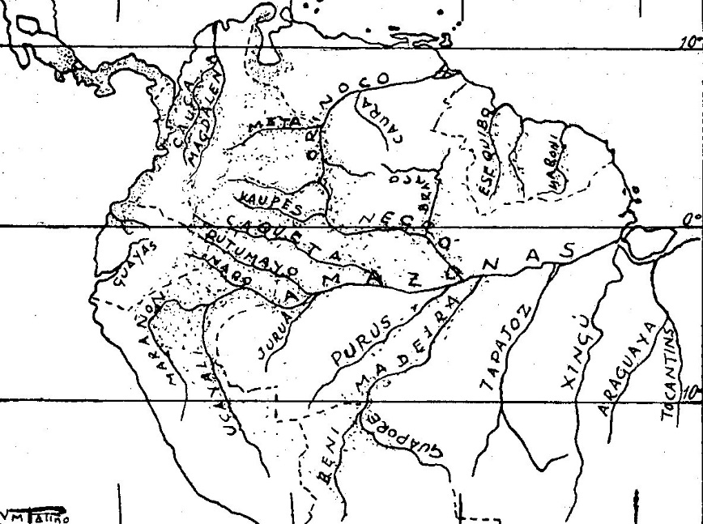
Figure S3. Distribution of reports about peach palm (Bactris gasipaes var. gasipaes) in the first centuries after European conquest of the Americas, compiled by Victor Manuel Patiño (1963: p.131).
References
Arroyo, C., and Mora-Urpí, J. (1996). Sobre origen y diversidade em pejibaye. Boletín Informativo Pejibaye (Guilielma) 5(1), 18-25.
Borchsenius, F., Pedersen, H.B., and Balslev, H. (1998). Manual to the palms of Ecuador. Aarhus, Denmark: University of Aarhus, Pontificia Universidad Católica del Ecuador.
Clement, C.R. (1988). "Domestication of the pejibaye palm (Bactris gasipaes): past and present," in The Palm - Tree of Life. Biology, Utilization and Conservation, ed. M.J. Balick. (New York: The New York Botanical Garden), 155-174.
Clement, C.R. (1990). Regeneração natural de pupunha (Bactris gasipaes). Acta Amazonica 20(1), 399-403.
Clement, C.R., and Coradin, L. (1988). Final report (revised): Peach palm (Bactris gasipaes HBK) germplasm bank. US AID, Proj. no. DAN-5542-G-SS-2093-00. INPA, Embrapa Cenargen, US AID, Manaus.
Clement, C.R., de Cristo-Araújo, M., Coppens d’Eeckenbrugge, G., Alves Pereira, A., and Picanço-Rodrigues, D. (2010). Origin and domestication of native Amazonian crops. Diversity 2(1), 72-106. doi: 10.3390/d2010072.
Clement, C.R., Rival, L., and Cole, D.M. (2009a). "Domestication of peach palm (Bactris gasipaes Kunth): the roles of human mobility and migration," in Shifting spaces, changing times: mobility, migration and displacement in indigenous lowland South America, ed. M.N. Alexiades. (Oxford: Berghahn Books), 117-140.
Clement, C.R., Santos, R.P., Desmouliere, S.J.M., Ferreira, E.J.L., and Farias Neto, J.T. (2009b). Ecological adaptation of wild peach palm, its in situ conservation and deforestation-mediated extinction in southern Brazilian Amazonia. PLoS One 4(2), e4564. doi: 10.1371/journal.pone.0004564.
Corrales-Ulloa, F., and Mora-Urpí, J. (1990). Sobre el proto-pejibaye em Costa Rica. Boletín Informativo Pejibaye (Guilielma) 2(2), 1-11.
Couvreur, T., Billotte, N., Risterucci, A., Lara, C., Vigouroux, Y., Ludeña, B., et al. (2006). Close genetic proximity between cultivated and wild Bactris gasipaes Kunth revealed by microsatellite markers in western Ecuador. Genetic Resources and Crop Evolution 53(7), 1361-1373. doi: 10.1007/s10722-005-5033-z.
Cristo-Araújo, M., Picanço-Rodrigues, D., Astolfi-Filho, S., and Clement, C.R. (2010). Genetic variability in the peach palm genebank with RAPD markers. Crop Breeding and Applied Biotechnology 10(3), 211-217.
Cristo-Araújo, M., Rodrigues, D.P., Astolfi-Filho, S., and Clement, C.R. (2015). Peach palm core collection in Brazilian Amazonia. Crop Breeding and Applied Biotechnology 15(1), 18-26. doi: 10.1590/1984-70332015v15n1a3.
d’Orbigny, A.D. (1847). Voyage dans l’Amérique méridionale: Palmiers [par Karl Friedrich Philipp von Martius]. Paris: Pitois-Levrault Strasbourg.
Dawson, I.K., Hollingsworth, P.M., Doyle, J.J., Kresovich, S., Weber, J.C., Sotelo Montes, C., et al. (2008). Origins and genetic conservation of tropical trees in agroforestry systems: a case study from the Peruvian Amazon. Conservation Genetics 9(2), 361-372. doi: 10.1007/s10592-007-9348-5.
Feeley, K. (2015). Are we filling the data void? An assessment of the amount and extent of plant collection records and census data available for tropical South America. PLoS One 10(4), e0125629. doi: 10.1371/journal.pone.0125629.
Henderson, A. (1995). The palms of the Amazon. New York: Oxford University Press.
Henderson, A. (2000). Bactris (Palmae). Flora Neotropica 79, 1-181.
Hernández-Ugalde, J.A., Mora-Urpí, J., and Rocha, O.J. (2011). Genetic relationships among wild and cultivated populations of peach palm (Bactris gasipaes Kunth, Palmae): evidence for multiple independent domestication events. Genetic Resources and Crop Evolution 58(4), 571-583. doi: 10.1007/s10722-010-9600-6.
Hollingsworth, P.M., Dawson, I.K., Goodall-Copestake, W.P., Richardson, J.E., Weber, J.C., Sotelo Montes, C., et al. (2005). Do farmers reduce genetic diversity when they domesticate tropical trees? A case study from Amazonia. Molecular Ecology 14(2), 497-501. doi: 10.1111/j.1365-294X.2005.02431.x.
Hopkins, M.J.G. (2007). Modelling the known and unknown plant biodiversity of the Amazon Basin. Journal of Biogeography 34(8), 1400-1411. doi: 10.1111/j.1365-2699.2007.01737.x.
Huber, J. (1904). A origem da pupunha. Boletim do Museu Paraense Emilio Goeldi 4, 474-476.
Miller, A., and Schaal, B.A. (2005). Domestication of a Mesoamerican cultivated fruit tree, Spondias purpurea. Proceedings of the National Academy of Sciences 102(36), 12801-12806. doi: 10.1073/pnas.0505447102.
Mora-Urpí, J. (1999). "Origen y domesticación," in Palmito de pejibaye (Bactris gasipaes Kunth): Cultivo e industrialización, eds. J. Mora-Urpí & J. Gainza Echeverría. (San José, Costa Rica: Universidad de Costa Rica), 17-24.
Morcote-Rios, G., and Bernal, R. (2001). Remains of palms (Palmae) at archaeological sites in the New World: A review. The Botanical Review 67(3), 309-350. doi: 10.1007/BF02858098.
Patiño, V.M. (1963). Plantas cultivadas y animales domésticos en América Equinoccial. Cali, Colombia: Imprenta Departamental
Patiño, V.M. (2002). Historia y dispersión de los frutales nativos del Neotrópico. Cali, Colombia: Centro Internacional de Agricultura Tropical.
Pearsall, D.M. (1992). "The origins of plant cultivation in South America," in The Origins of Agriculture: An International Perspective, eds. C.W. Cowan & P.J. Watson. (Washington, DC: Smithsonian Institution Press), 173-206.
Pintaud, J.-C., Galeano, G., Balslev, H., Bernal, R., Borchsenius, F., Ferreira, E.J.L., et al. (2008). Las palmeras de América del Sur: diversidad, distribución e historia evolutiva. Revista Peruana de Biologia 15(1), 5-27.
Pulliam, H.R. (2000). On the relationship between niche and distribution. Ecology Letters 3(4), 349-361. doi: 10.1046/j.1461-0248.2000.00143.x.
Ríos-Reyes, L.D., Castillo-Hernández, E., and Fuchs-Castillo, E.J. (2016). Estado actual del banco de germoplasma de pejibaye (Bactris gasipaes), Guápiles, Costa Rica. Agronomía Mesoamericana 27(2), 311. doi: 10.15517/am.v27i2.20737.
Rodrigues, D.P., Astolfi Filho, S., and Clement, C.R. (2005). Molecular marker-mediated validation of morphologically defined landraces of pejibaye (Bactris gasipaes) and their phylogenetic relationships. Genetic Resources and Crop Evolution 51(8), 871-882. doi: 10.1007/s10722-005-0774-2.
Ruiz, H.L., and Pavón, J.A. (1798). Systema vegetabilium florae peruvianae et chilensis. Madrid: Typis Gabrielis de Sancha.
Saldías-Paz, M. (1993). "La chonta de castilla (Bactris gasipaes H.B.K.): taxonomía y algunos datos económicos em Santa Cruz y su distribución en Bolívia," in Anales del IV Congresso Internacional sobre Biologia, Agronomia e Industrialización del Pijuayo, eds. J. Mora Urpí, L.T. Szott, M. Murillo & V.M. Patiño. (San José: Editorial Univ Costa Rica), 115-126.

