“Faidherbia-Flux”: a new long-term Collaborative Observatory on GHG fluxes and ecosystem services in a semi-arid agro-silvo-pastoral ecosystem (groundnut basin in Niakhar/Sob, Senegal)

O. Roupsard^{1,2}, C. Jourdan^{1,2}, L. Cournac^{2,3}, L. Tall⁴, Y. Ndour⁴, E. Gaglo⁴, DeMarchi^{1,2}, G., M. N’dienor⁴, R. Diatte³, A. Audebert^{5,6}, E. Faye¹⁹, L. Kergoat⁷, F. Timouk⁷, M. Grippa⁷, F. Gangneron⁷, D. Orange², W. Faye^{2,18}, A.N. Fall¹⁸, F. Do², A. Rocheteau², M. Duthoit², C. Clermont-Dauphin^{2,3}, L. Chapuis-Lardy^{2,3}, D. Masse², R. Manlay^{2,17}, K. Van den Meersche², R. Lalou¹⁶, L. Fleury⁸, R. Fensholt⁹, J. Ardö¹⁰, T. Tagesson¹⁰, R. Hijmans¹¹, A. le Quéré¹², T. Wade¹², V. Soti^{13,14}, L. Leroux^{13,14}, S. Taugourdeau¹⁵, J. Seghieri¹⁶, J.P. Laclau², J.L. Chotte²
¹CIRAD, UMR Eco&Sols, LMI IESOL, Dakar, Senegal; ²Eco&Sols, Univ Montpellier, CIRAD, INRA, IRD, Montpellier SupAgro, Montpellier, France; ³IRD, UMR Eco&Sols, LMI IESOL, Dakar, Senegal; ⁴ISRA, Dakar, Senegal; ⁵Cirad, UMR AGAP, Montpellier, France; ⁶Cirad / ISRA-Ceraas, Thies, Senegal; ⁷Géosciences Environnement Toulouse (GET), CNRS/IRD/Université de Toulouse, Toulouse, France; ⁸Aix Marseille Univ, IRD, LPED, France; ⁹Department of Geosciences and Natural Resource Management, University of Copenhagen, Copenhagen, Denmark; ¹⁰Lund Univ, Phys Geog & Ecosyst Sci, Lund, Sweden; ¹¹Univ Calif Davis, Dept Environm Sci & Policy, Davis, USA; ¹²Univ Montpellier, Lab Symbioses Trop & Mediterraneennes CIRAD, INRA, IRD, Montpellier SupAgro, Montpellier, France; ¹³Cirad, UPR Aida, Montpellier, France; ¹⁴CSE, Dakar, Senegal; ¹⁵CIRAD, UMR SELMET, Montpellier, France; ¹⁶Univ Montpellier II, Inst Rech Dev IRD, UMR Hydrosci Montpellier, MSE, Montpellier, France; ¹⁶UMR MERIT, Paris, France, ¹⁷AgroParisTech, Paris, France; ¹⁸UCAD, UMI RESILIENCES, Dakar, Senegal, ¹⁹CIRAD, UPR Hortsys, Dakar, Senegal
“Faidherbia-Flux”, a new long-term highly-instrumented observatory of the critical zone of Sahelian western Africa has been launched early 2018 through international cooperation. We aim at fostering agro-silvo-pastoralism and sustainable intensification research. Namely, ecosystem services, GHG (CO₂, H₂O, N₂O, CH₄) fluxes and balances, annual crop (millet, groundnut, cowpea, water melon…) production, the role of livestock, and the effects of management options are targeted.

The initiative is hosted at the Niakhar Health-Population-Environment Observatory (> 50 yrs. of past research). We chose a Faidherbia albida tree parkland owing to the attractiveness of this species that is maintained by the people, exhibits reverse phenology, N₂ fixation, phreatophytic behavior (hydraulic redistributions?), forage for animals during the dry season, and positive effect on crops, microclimate and infiltration. We assume Faidherbia is a lever for ecological intensification, compatible with other levers, such as mixed crops, livestock, or precision agriculture).

To date, “Faidherbia-Flux”¹ offers:
- Eddy-covariance (EC) measurements (30 m tall tower) since February 2018 for CO₂, H₂O and energy over the whole ecosystem, with ancillary measurements (soil temperature profile and humidity) (UMR Eco&Sols, LMI IESOL). Drone cover (UMR AGAP, UMR SELMET).
- 2 towers (4 m) over millet (UMR Eco&Sols, LMI IESOL) and groundnut+cowpea (GET AMMA-CATCH), recording the 2018 wet season
- One field trial in 8 blocks to assess and model the effect of cowpea on millet (ISRA+ UC Davis)
- 8 stations for hydrology (infiltration, aquifers, salinization, N transfer) and hydraulic redistributions (sapflow) experiments under construction (UMR Eco&Sols, UMI RESILIENCES)
- Minirhizotrons and automatic root scanners under construction (UMR Eco&Sols, LMI IESOL)
- Soil gas exchange (CO₂, N₂O, CH₄) experiments under construction

Our philosophy is to mutualize efforts into one complex but representative ecosystem and for the long term. Collaborations for science & development are highly welcome. Any scientist, student, institution, NGO… can apply. Complementarity and facilitation will be fostered, overlaps will be minimized. Expected outcomes include high-level trans-disciplinary research, common projects, training, networking, international visibility…

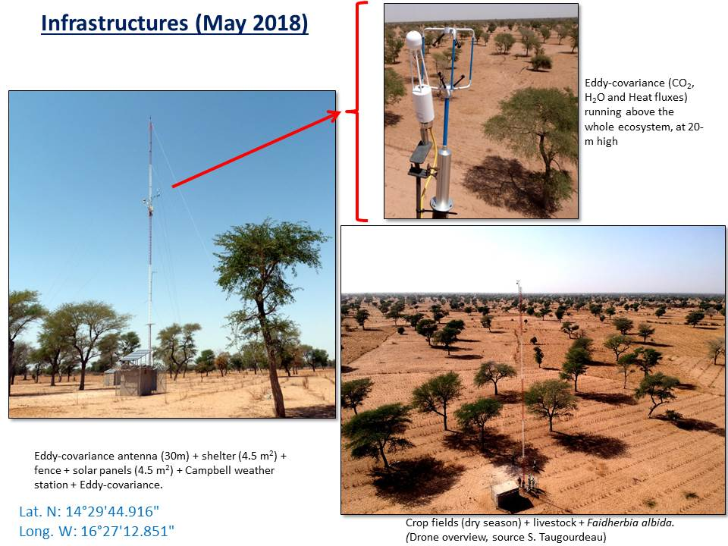

AGRAF : http://agraf.msem.univ-montp2.fr/Senegal.html
OPSE Niakhar : http://ppr-srec.org/observatoires-fiche/lobservatoire-de-population-sante-et-environnement-de-niakhar.html

