Unité HortSys

Document de travail n° 22
Projet FORECAST
UMR INNOVATION/UR HORTSYS

Clove products sustain agroforestry, sustainable agriculture and farmers’ incomes in Northeastern Madagascar

Eric Penot (1), Pascal Danthu (2),

1 : CIRAD/UMR Innovations, 73, rue Jean-François Breton - 34398 Montpellier Cedex 5
France, eric.penot@cirad.fr,

2 : CIRAD/ UR Hortsyst , pascal.danthu@cirad.fr,

Montpellier Mai 2020

Clove products sustain agroforestry, sustainable agriculture and farmers’ incomes in Northeastern Madagascar

Summary
Clove began to be planted in Madagascar on the eastern coast since 1910 originally by French settlers, rapidly followed by local farmers, attracted by this culture as a valuable cash crop. The current plantations, entirely smallholding, date from 1920-1930 and 1950-1970 planting booms. Some local farmers do profit from the current remaining resource more on a logic of “extractivism” when other farmers have a real a logic of plantation and do replant in particular since 2010 with good prices of clove products (clove bud and oil). Typhoons, diseases and ageing lead to a decrease in clove plots tree planting density and a move to parks and complex agroforestry systems. Currently, clove contributes globally to 50 % of rice purchases to assure farmers’ food security in Fénérive-Est area. Clove cropping patterns are diverse: i) residual monoculture, ii) clove parks with annual crops and grazing period) and iii) clove complex agroforestry systems with timber trees and fruit trees. The clove tree has two different products: clove buds (irregular inter-annual production) and essential oil (regular annual production) with different management leading to different farmers’ strategies. Market prices or both clove and oil are very volatil leading to changes in local strategies. However, clove prices are very good since 2010 and sustain a real replanting in Analajirofo/Fénérive-Est area and a boom in Mananara but not in Sainte Marie, the cradle of clove in Madagascar, mainly for social reasons. Income analysis shows that most farmers cope with decreasing clove production trough system diversification and increase of oil production, clove products being the main component of indirect food security in the area.
Key words: clove, agroforestry, clove oil, Madagascar

1 Introduction

1.1 The role of clove in Madagascar.

The clove tree (Syzygium aromaticum) is one of the most important cash crops in the eastern region of Madagascar cultivated for more than a century (DANTHU et al, 2014) with vanilla and litchi. Originally from the Moluccas Island in Indonesia the clove tree was introduced on the Island Saint Marie of Madagascar in 1822 and then disseminated on the eastern coast of Madagascar main land after 1900 with the French settlers (JAHIEL, 2010). Very rapidly, local farmers adopted clove to generate cash required to buy rice and pay taxes. According to the previous studies regarding clove tree based cropping systems in Madagascar (MICHELS ET AL., 2011; PENOT ET AL., 2011, ANDRIANARINA et al, 2010) the current plantations are issued from both colonial implantations and smallholders plantations established mainly in 2 periods: initially in the 1930’s and in a second boom in the 1950-1970’s period on the eastern coast. If French settlers planted in monoculture, most farmers began as well to plant in agroforestry systems as clove requires shade at early stage. The income generation from cloves trees played historically and still nowadays an important role for the local Bestimisaraka farmers that contribute to farmers’ livelihoods as well as to the national economic output as clove Products became in 2012 the first agricultural export value in Madagascar. Madagascar is the second biggest producer of cloves and essential oil after Indonesia and the number one exporter (FAOstat, 2013) providing 7.6 % in value of country global export.
The region of Analajorofo, which means “clove trees forest”, achieved an average production of 6-7 000 tons/year with more than 30 000 local farmers in the district of Fenerive-Est, the old production area, and probably the same number in Mananara, the new production area which are our two study areas with 90 % of the national production (MINAGRI; 2011). The production of Sainte Marie island as the craddle of clove in the country is not anymore significative and has been studied in another paper (PENOT et al, 2019 in process). In Fénérive-Est The aging trees, the apparent lack of replanting during the 1990’s and typhoon effects between the 1960s and the 2000s have led to the alteration of the plantations structure and function (PENOT, 2011). Clove is the source of two different products: dried clove (buds) and clove essential oil. Madagascar has a main position on both markets as exporter. But good prices for both clove buds and clove oil have boosted production and replanting since 2000 with a real and consistent boom after 2010.
The main question is: what is clove products (buds and oil) contribution to farmers’ income today?
The objective of this article is to understand the factors that created such an evolution to clove as the main farmers’ income contributor. Clove has 3 main features: i) two final products: clove buds and clove essential oil, ii) current plantations have been established with non-selected planting material as no research or selection has ever been done to select improved varieties and iii) the very long lifespan of clove lead to various type of behavior concerning plantation and replantation strategies: from “extractivism like” exploitation to patrimonial exploitation. 3 main types of clove cropping systems have been identified; monoculture, parks (with annual crops) and agroforestry systems (with trees and/or perenial crops).
Uses of clove are varied and market is dependent on the level of production and the Indonesian demand (essentially low quality CG3) (HANUSZ, 2002). Even if the demand for clove-quality spice and eugenol (clove essential oil) have good prospects. Clove is also a spice used in many Eastern and Western cuisines (TEUSCHER et al. 2005). The clove is known for its antiseptic and anesthetic properties, it is used for a long time in dentistry, cosmetic and perfumery. But most of the world production us used in the manufacture of traditional Indonesian kretek cigarettes composed of a mixture of tobacco and cloves (FRANCOIS 1936 TEUSCHER et al 2005 (DUCLOS 2012). RUF (2000) estimated that about 75% of world clove production was in the 1980s, for the manufacture of kretek. Clove oil is produced by distillation of leaves produced in a variety of rudimentary stills installed in each village. The global production does not seem to cover the needs which explain the relative high prices since the 2000’s. Today Madagascar is the top exporting countries for clove and oil, since the 1990’s (TEUSCHER et al, 2005, FAOSTAT 2013).

1.2 Clove prices evolution
Indonesia plays a key role as a price maker when most of the production go first trough Singapore playing the role of local trade hub allowing as well to by-pass the long time forbid of clove import to Indonesia (70 % of production and 80% of global consumption). The fall of the Indonesian production in 1998 help to maintain domestic prices artificially low that resulted in a uptrend and a surge in 2001 and 2002 (JAHIEL, 2010). Such situation boosted the demand from Madagascar, Tanzania (Zanzibar) and from “Union des Comores” Since 2005, Indonesian production remained at around 75,000 t/year and world production around 100,000 T. Madagascar is the second largest exporter before Tanzania (Zanzibar). Figures 1 and 2 show the evolution of the price paid to local producers in Madagascar for clove and essential oil. The price curve generally follows the price on the international market.

Map n° 1. Study area
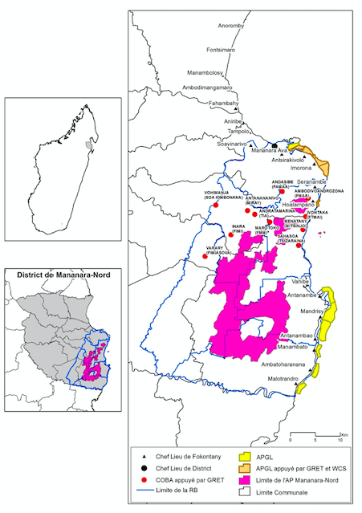

Study area in Mananara: Fokontany/village of Sahasoa, Andratamarina et Antanananivo, county of Mananara-Nord
(source: De Rouvray C, 2017)

Study area in Fénérive-Est: Fokontany/village of Mahavanona for the county of Mbodimanga II and Fokontany/village of Ambodihazinina for the county of Ambatoharanana. (source: Lobietti, 2013)

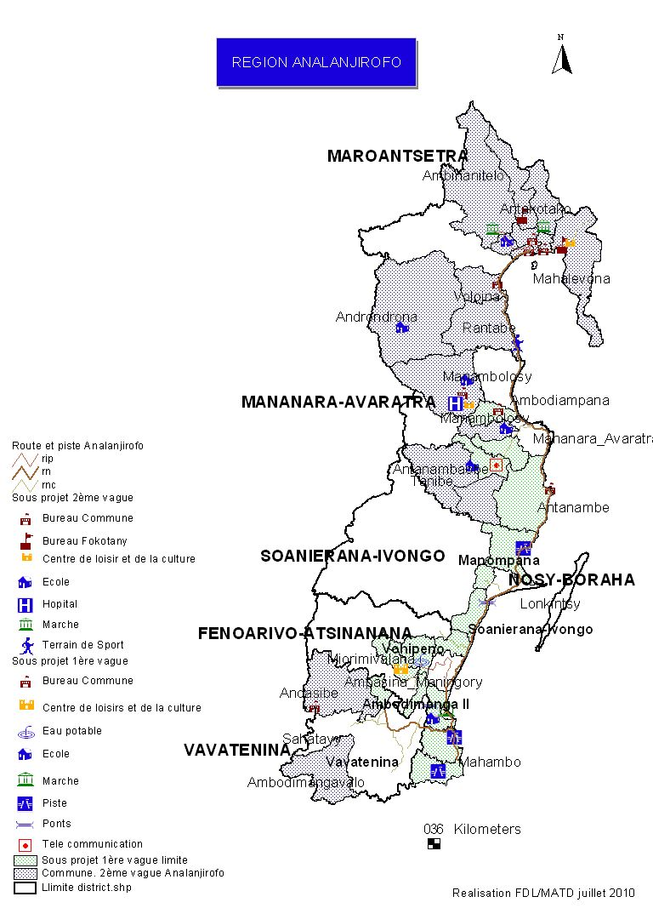
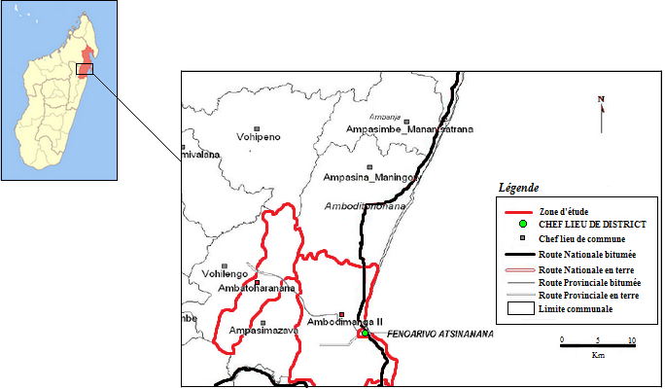

Zone of study area
in Sainte Marie Island

Figure 1: Clove bud farm gate price evolution from 1967 to 2013

The clove oil prices follow an upward trend from 1965 to 1974 and then due to the oil crisis remained low until 1991. The evolution of the FOB price of clove oil from 1996 to 2010 (Figure 2) shows the upward trend since 1996 and the very recent important but consistent increase since 2010.

Figure 2: FOB clove oil price evolution in current in Ariary per kg (1996-2013).

Sources : Dufournet, 1968 (1949-1967); INSTAT (1968-1974, 1981-1984, 1991, 1996-2008), BCM/MINCOM, DPEE/SPE (2009-2010).

Clove bud market is relatively regular and fixed, strongly linked with the Indonesian market (however production is highly irregular but buffered by Singapore playing the role of stocking “hub”). Essential oil market is booming since 2010. Clove products price is the main leading factor of clove tree management, production and replantation.

2 Materials and methods
Three socio-economic surveys have been conducted: i) in 2012/2013 In Sainte Marie with 35 farrmers in the villages of Ambatoroa and Ambohitra, ii) in 2013/2014 in Fénérive-Est area, Alananjiroflo province with 33 farmers in the villages of Mahavanona, and Ambatohorana and iii) in 2017 in Manananara province with 37 farmers in the villages of Sahasoa, Andratamarina et Antanananivo (see map 1).
The annual rainfall in the region varies between 180 and 300 days per year, with the monthly average precipitation from 80 to 160 mm during the wet season (October to April). In the dry season, from April to September, there is less rainfall and the average temperature is 25°C. The landscape in the study area is predominantly characterized by lowland rice and hilly fields covered with clove trees on the slopes varying from 20-120 m in elevation. The landscape has been changing since the 1920s with the introduction of clove trees, in replacement of an old ageing colonial coffee plantation suffering from leaf disease.

Sampling and data collection
The study employed qualitative and quantitative collection methods with 105 in-depth semi-structured farming systems interviews in the 3 provinces and discussions with 7 focus group at the beginning of the survey and at the end for validation (in each village).
Participatory rural appraisal (PRA) methods were applied to supplement data collection (preference matrix), timeline and mapping (MIKKELSEN, 1995), active participatory observation and transect walks with key informants. PRA offers the advantage of learning with and from rural people, interacting daily and directly, on the site (CHAMBERS, 1990). The tree population was counted in 27 plots in the two villages in Analanjiroflo province, 27 plots in Sainte Marie and 30 in Mananara. The typology of the clove cropping system identified in Madagascar by MICHELS et al. (2011) and PENOT et al. (2011) was used in the survey to characterize the measured plots, the knowledge and use of the crops by local population. The main uses of the plant species were identified through interviews with local farmers. The species were then grouped into one of the following classes: edible, medicinal, timber and other.
Survey results were compiled in 3 Excell sheets (one per province) and then processed using the software Olympe (farm budget simulation, PENOT, 23012) in common one data file.

3 Main Results

3.1 A typology of clove based cropping systems with focus on parks and complex agroforestry systems.
The typology of clove cropping systems in the region has been identified in 2012 (DANTHU et al, 2014):
- Clove monocropping or monoculture (5 to 10 % of the area): from ancient clove plantations at colonial time with very high planting density (500 to 600 trees/ha). The trees are old (> 50 years) with an average number of 320 plants per hectare (Table 3). Clove tree mono-cropping system seems to be preferred by older farmers because it requires less labor and is easy to maintain (MICHELS et al., 2011): low weeding, no pruning and re-plantation of dead clove trees.
- The parkland cropping system (70 to 75 % of the area) could have two origin: either coming from a former clove tree plantation with many missing trees permitting food-crops to grow (upland rice, sweet potato, cassava, maize or groundnut). The scattered clove tree canopies permits the intercalation of food crops. The main priority of the farmers is to meet the family’s basic food needs (Tab. 2). The parkland plots have an average surface of 0.31 ha. In the case of such mixed plantation (trees + food-crops), the labor demand for the system is higher than in monoculture. New parklands appear as a solution for the farmers to achieve food production before the cash crops are reaching their maturity.
- The clove tree complex agroforestry system (AFS) (around 20 %): Agroforestry systems are land-use systems with a complex, dense, multi-strata structure comprising many perennial species on the same land unit generally based on one main species (TORQUEBIAU, 2000). Clove systems evolution displays adaptation due to progressive loss of the trees and diversification through the development of annual food-crops as intercropping in parklands and associates fruit and timber trees in agroforests. Know-how local knowledge and practices influence the choice of the farmers for a farming system will allow analyzing the producers’ livelihood strategies.

Complex Agroforestry Systems are more and more developed with a clove tree density between 100-250 trees/ha (Table 3) and associated cash crops (cloves, coffee, litchi, vanilla, fruits and timber) that contribute to family income, with cloves accounting for 20-50 % of the cash income (PENOT et al., 2011).Table 1 and 2 displays the characteristics of clove systems in Fénérive-Est and in Sainte Marie where agroforestry systems are predominant in this island.

Table 1 Characteristics of clove tree cropping systems in Fenerive-Est.
Type of cropping system  Variables | Monospecific  (10 %) | Complex agroforestry systems (AFS) 30 % | Parkland  (60 %)
Average Surface (ha) | 0, 49 | 0, 25 | 0,31
Nr of plots per producer | 3,25 | 4,22 | 3,27
Nr of inherited clove trees per plot | 32 | 20 | 19
Nr of planted clove trees per plot | 92 | 65 | 41

Figure 3 Trees distribution and share of cloves in AFS (including banana) in Fenerive East.

Coffee (C. Canephora) was introduced in the region before clove trees (1900s) (RAMILISON, 1985) but were damaged by a fungus attack in the early 1930’s: « Hemileia vastarix » (RAMILISON, 1985). Old coffee trees were rapidly replaced with clove trees including agroforestry practices as cloves need shade at early stage. Trees with edible products are most planted as farmers rely on them to complement family’s food production. Exotic fruits trees (breadfruit tree with 10 to 20 %) jackfruit with 10 to 25 %, mango tree with 5 to 10 %) and timber trees (Grevilea, Albizzia, Ravelana ..) are the most planted or retained trees after clove trees, along with cinnamon, banana, residual coffee trees and firewood species.
In agroforestry systems, the clove and litchi trees are the most economically valued trees: 30-60 % cash crops with 20 % of fruits trees (mangoes, jackfruits, avocado, coffee…), and 20 % of timber trees (Arongana, Grevilea qpp, Albizzia spp…). 18 different species associated with clove trees have edible fruits (Table 3); other 10 different species are used in the construction or as timber or fuel wood and 8 trees are considered by farmers as enriching the soil quality (Table 4). Farmers did not specify any medicinal uses for the trees, but highlighted the importance for self-consumption of fruits including bread fruit as momentary stapple food. Among the edible trees, only one is native to the region while 17 are exotic fruits. The loss of local tree biodiversity is evident. Beyond producing clove trees, farmers rely on agroforestry outputs such as litchi for 14 out of 33 producers (1 to 6 producing trees per farm contribute to 20 % to total agricultural income as a single tree can provide 200 kg of fruits/year) and coffee. Once very important in the area, old coffee trees (8 out of 33 producers) varying 1-40 trees per farm with a low production of 2 kg/tree/year.

3.2 Socio-economic analysis of farmers in FeneriveEst
In Analanjiroflo province (Fénérive-Est), clove producers are aged between 26-91 years, with 60 % older than 50 years, an aging population. Six producers (out of 33) have more than 50 years of experience. The majority of the farmers are men (85%). The other important factor is the level of education; 64 % attained primary education, and 18 % only secondary school. Producers with some years of education are more prone to get an agricultural training. On average, families have between 2-8 members. From the villages’ census, the active population (>18 years) of the families represents 49 %. The land rights are clear and few problems occur. Land acquisition is through inheritance from the parents (39%), purchase (9%) or both inheritance and purchase (45%). The clove cropping systems distribution is the following: monocultures (5-10%), clove agroforestry systems (20%) and parklands, crops under clove trees, represent 70-75% (Tab.1). The number of producing clove trees is determinant for the income: i) less than 50 trees per farm (50%), ii) between 50 and 100 trees (25%) and iii) more than 100 trees per farm (25%). Current plantations were planted: i) from emerging seedlings under old trees (76%), ii) given from neighbors (12%) or iii) purchased by 12 % of producers.
Besides agriculture, which is the core activity for 80% of respondents and generates income from cash crops (litchi, cloves, coffee, vanilla….), the second most important income generating activity is the livestock (63%), where most of the farmers have at least one zebu (used as financial “spare” capital and for tillage) and rear pigs and poultry. Most of the food-crops are self-consumed. Off-farm activities include artisan work (8%), commerce (16%) and associations (12%). Clove production generates for farmers, an important but very irregular income from one year to another. Clove oil production provides an opportunity for a better and regular source of income to cover annual livelihood expenses or specific or sporadic need (lean reimbursement, home improvement, health, ceremony ...). Clove bud income is generally used for investment or a commemorative feast when clove oil income allows a regular income to ensure food security. Farmers have developed an adapted and efficient management of clove trees concerning clove bud and essential oil production in order to meet their own requirements. Fourcin (2014) shows that tree management result form a good farmers’ knowledge of tree physiology and management between clove bud and oil productions.

The economic performances of clove tree cropping systems are being calculated including both products cloves and essential oil. As seen in figure 4 for Anlanajiroflo area, the clove trees contribute in average to 40 % of the households’ income generation. The low cost of production (with low investment) and the relatively high yields of the 2 products make clove the most local important crop to achieve food security, complementing local rice production. Livestock contributes to 26 % showing the relative importance of livestock production and diversification as well as other cash crops such as litchi (19 %), coffee (6 %) and vanilla (4 %).

Figure 4. The agricultural activities and origins of households’ income in 2 villages of the Fénérive-Est/Analajiroflo area.

The farmers’ typology (FOURCIN et al, 2017))
The typology is presented in figure 5

Figure 5: Farm typology for Fenerive-Est area

Figure 6: agricultural income evolution on 10 yeards for various farm types.
Farm type A and B produce clove buds and oil, Farm type C and E focus on oil production. Farm type DO and DG focus on clove bud production.

The alternation of production between years is more pronounced for types B and DG who have more clove trees than other types. On the other hand, type B farmers consume more than type A farmers, their standard of living being higher and they send their children to more distant schools. As a result, the cash balance of type A farmers is also higher than that of type B farmers. The types DO and DG have a high agricultural income and a better standard of living. Clove products play the predominant role in income formation: the more clove trees the highest incomes. Household investment capacity (cumulative cash balance) ranges from a factor of 1 to a factor of 9 in ten years. This mode of management of clove trees that favors essential oil is mainly adopted by farmers with productive cloves (66%).

3.3 Socio-economic analysis of farmers in Mananara
The construction of the structural typology is based on 24 farm households out of 37 surveyed.
The criteria of self-sufficiency in rice, purchase/sale of rice and origin of income led to the creation of the 6 types, defined in Figure 7 (DE ROUVRAY, 2017).

Figure 7 : farm typology inMananara (C. de Rouvroy, 2017)

The table 2 displays the origin of total net income by farm type with agricultural income providing between 40 to 100 % of the total income. Except the SO type, off farm income is very limited and clove products provide 20 to 66 % of the agricultural income. The characteristic feature of Mananara area is the very low impact of oil production on incomes (3 % for SO type only) as clove essential oil production is really beginning.

Tableau 2: Origin of income for different type of farms after (C. de Rouvroy, 2017)
Name |  | % in farm | % Off-Farm | % Rice | % clove products | % clove buds | % clove oil | % Vanilla | % Livestock
Type SO |  | 40% | 60% | 0% | 51% | 48% | 3% | 49% | 0%
Type SV |  | 88% | 14% | 2% | 24% | 24% | 0% | 66% | 9%
Type AG |  | 100% | 0% | 1% | 60% | 60% | 0% | 37% | 2%
Type AV |  | 89% | 11% | 0% | 19% | 19% | 0% | 72% | 8%
Type NG |  | 100% | 0% | 0% | 66% | 66% | 0% | 34% | 0%
Type NV |  | 100% | 0% | 0% | 13% | 13% | 0% | 83% | 4%

3.4 Socio-economic analysis of farmers Sainte Marie
In Sainte Marie, farmers do not invest in any input and the only cost is external labor for harvest and pruning. Land status is mare more complicated in this island with the existence of different types of rights belonging to potentially different people: rights on land, rights on trees, right of avail on woodfuel, clove leaves and cloves buds. Clove plantation provide between 25 to 55 % of total agricultural gross income. Besides cloves, other crops and activities do complement the households’ income (Figure 5) with other agricultural product for 20 to 40 % (honey, fruits, fuelwood ….), fishing (15 to 20 %) and other off-farm activities (3 to 15 %).

Figure 5: origins of households’ source of income in Sainte Marie island (A Richard and E Penot, 2013)

4 discussion

4.1Preference for clove products and their complementarities
The preference matrix and focus group discussions lead to preference identification for the 2 clove tree products with different objectives: clove buds for the facility of harvest (but only every 3 years) and good return to labor and clove oil (mainly in Mananara) is as “de facto” the income adjustment variable as it can be done when either it is necessary leading to a very flexible source of income (mainly in Févérive-Est area).
The essential oil in Madagascar is extracted from the clove leaves, which contains 75 - 98% of eugenol (DANTHU, 2014) and this activity is essentially implemented in Anlanjirofo (including Sainte Marie) and not in Mananara. Upper branches do not develop clove buds and pruning that uses leaves for distillation may jeopardize clove bud production if not properly done at least the producing years (1 out of 3 in average) (FOURCIN et al , 2014)
Clove oil distillation can be done any time of the year however rainy season is less favorable (figure 5). The recent increase clone oil production, since 7 years, at national level, can be partially explained by a more important use of the leaves with limited effect on clove bud production in order to maintain a more regular income at farm level. Farmers can stock clove and oil and wait for a better price. As it is already a flourishing activity in Fénérive Est, there is no doubt that it bill very rapidly developed itself in Mananara. In Mananara; the valinna production complements farers income and currently takes place of essential oil as it is the case in Fénérive–Est area. In Sainte Marie, clove production (either buds or oil) are declining and replacers by off farm activities (fuel wood production, honey and fishery).
Apparently antinomic, both products of clove buds and oil are in fact complementary contributing to the farmers’ income if managed in good conditions. Farmers know how to manage such complementary: before starting to prune they look and identify the flower buds in order to cut down branches with no flowers. In fact, clove oil is the basic regular source of income, adaptable to actual farmers’ needs when clove production can be more considered as an “opportunistic” but irregular income.

4.2Constraints to the (re)planting
Albeit an apparent motivation to replant is observed, farmers obviously have to cope with the lack of clove seedlings under their own trees due to the following conditions; i) clove new shoots are destroyed by annual crops or zebu grazing and ii) clove new shoots cannot grow properly under the high shade in mature clove based agroforestry systems. Most farmers prepared their own seedlings in their small private clove nurseries.

4.3 Taking advantages from agroforestry systems with clove

Table 3 Main uses of plant associated to clove trees in agroforestry systems according to farmers’
perception

Specie | Family | Native/ exotic | Emerged / planted | Construction /fuel wood/ timber | Consumption/ spicy | Medicine | Sale | Soil fertility | Handycraft
Acacia Mangium | Fabacées | Native | Emerged | X
Albizzia falcateria | Fabacées | Native | Planted | X |  |  |  | X | x
Ambarella (Spondias dulcis) | Anacardiacées | Exotic | Planted |  | x |  |  | X
Bread fruit (Artocarpus altilis) | Moracées | Native | Emerged | X | x |  | x
Bambous (Ochlandra capitata) | Poaceae | Native | Emerged | X |  |  |  |  | X
Bananier | Musacées | Exotic | Planted |  | x |  | x
Coffee (Coffea canephora) | Rubiacées | Exotic | Planted |  | x |  | x
Cinnamon (Cinnamomum verum) | Lauraceae | Exotic | Planted |  | x |  | x
Coconut (Cocos nucifera) | Cocotae | Exotic | Planted | X | x |  | x |  | x
Eucalyptus (Eucalyptus robusta) | Myrtaceae | Exotic | Planted | X |  |  |  |  | x
Grevillea banskii | Proteaceae | Native | Emerged | X |  |  |  | X | x
Guava (Psidium guajava) | Myrtaceae | Exotic | Planted |  | x |  | x
Haronga (Harungana madagascariensis) | Clusiaceae | Native | Emerged | X |  |  | x
Jack fruit (Artocarpus integrifolia) | Moraceae | Exotic | Planted |  | x |  | x
Litchi (Litchi chinensis) | Sapindaceae | Exotic | Planted | X | x |  | x
Rambutan (Nephelium lappaceum) | Sapindaceae | Exotic | Planted |  | x |  | x
Longoza (Aframomum anguitifolium) | Zingibéracées | Native | Emerged |  |  | x |  | x
Makoba (Staudtia kamerunensis) | Myristicaceae | Native | Emerged
Mango (Mangifera indica L.) | Anacardiaceae | Exotic | Planted | X | X |  | x
Ravinala (Ravenala madagascariensis) | Strelitziaceae | Native | Emerged | X
Rafia (R. farininfera) | Arecaceae | Native | Emerged | X |  |  |  |  | x
Papaya (Carica papaya L.) | Caricacées | Exotic | Planted |  | x |  |  | x
Pepper (piperum nigra) | Piperaceae | Exotic | Planted |  | x
Orange (Citrus sinensis L.) | Rutacées | Exotic | Planted |  | x
Soursop (Anona muriacata) | Annonaceae | Exotic | Planted |  | x |  | x
Sugar-apple (Pinha annona) | Annonaceae | Exotic | Planted |  | x |  |  | x
Vanille (Vanilla planifora) | Orchidaceae | Exotic | Planted |  | x |  | x
Ylang ylang (Cananga adorata) | Annonacées | Exotic | Planted | X | x |  | x
Table 3 Main uses of plant associated to clove trees in agroforestry systems according to farmers’ perception

Conclusion

The current Malagasy clove industry is the result of the convergence of several favorable and historical factors. The first factor is the balance between the ecological requirements of the plant and the environmental context of the east coast of Madagascar, although its sensitivity to cyclones. The second factor was the rapid adoption by local farmers who integrated it very quickly in their production system, mainly due to the low requirement in terms of care and maintenance with a very limited initial investment. Clove bud harvest and preparation are relatively easy and substantial income is generated by the two products (buds and oil). A third positive factor was the growth in global demand and made it a real best-bet cash crop with high added value compared to other (in particular coffee historically). The fourth is related to the innovation of oil production and the strong interest that different industrial sectors with high added value marked for eugenol leading farmers to rapidly valorize clove leaves.

At the producer level, there is historically a progressive transition from a resource management economy (in the 1950’s) to a type of “extractivism” based on an existing nut not entirely renewed ageing resource (period 1960-1999). The good prices since 2000 and particularly 2010 trigger replanting and the return of economy plantation in farmers strategies. The clove resource is still considered as sufficient in its current state by local farmers and current replanting seems to renew the resource. However, the generational fragmentation of farms (in average every 30 years) trough inheritance and a relatively high population increase above 3 %/year will rapidly lead farmers to reconsider their current perception if they want to maintain food security in the mid-range. Farmers’ strategies on cropping patterns are as well influenced by external factors (price fluctuations and climatic conditions altogether). Parklands with clove and annual food-crops is a strategy to optimize land utility and ensure food production. Clove agroforestry systems are more diversified in terms of species and ecological and economic benefits, where income from associated crops depends on markets proximity. Dealing with two products, clove and oil, allow farmers to cope with prices volatility and adapt productions to their needs.

May be a very particular point has been the very few policies developed for clove since independence: a perennial crop project in the 1960/70’s and a small replanting program in the 2000’s which is quite few for the first /second largest agricultural export in value of the country. The private sector is mainly concentrated on collecting, grading and exporting the 2 products. The production sector is entirely “atomized” with almost no farmers groups. Exporters have recently created an association (GEGM as “Groupement des Exportateurs de Girofle de Madagascar”/Clove Exporters Association). All innovations in cropping systems and clove/leave management have been done by farmers themselves without any support. Local know-how led to agricultural practices trying to balance food production for self-sufficiency and cash crop for income generation. Annual upland crops in parks have a very low productivity and generate erosion when agroforestry systems are far more sustainable and economically interesting trough product diversification and environment friendly through soil protection. The trade-off is between Park/immediate output vs agroforestry systems/long term sustainability. Most farmers as well know how to manage clove bud and essential oil production at tree level to enable both productions when clove bud production provides an irregular money fall and essential oil a regular basis income.

Acknowledgment
This work was supported by the UE/EU/AFS4FOOD and Agropolis/FORECAST projects in Madagascar.

Références
ANDRIANIRINA N., BENOIT-CATTIN M., DAVID- BENZ H., 2010. Diversité, diversification et inégalités chez les ménages ruraux. Le cas de l’observatoire rural de Fénérive Est à Madagascar. Actes des 4èmes journées INRA-SFER-CIRAD de recherches en sciences sociales. [http://www.sfer.asso.fr]. Accessed 30th november, 2013.
CHAMBERS R. (1990). Rapid and Rural Participatory Appraisal (PRA). Appropriate Technology Vol. I 6 No 4.

DANTHU P, PENOT E, MAHAFAKA RANOARISON K, RAKOTONDRAVELO JC, MICHEL-DOUNIAS I, TIOLLIER M, MICHELS T, NORMAND F, RAZAFIMAMONJISON G, FAWBUSH F, JAHIEl M. 2014. The Clove tree of Madagascar a success story with an unpredictable future. Bois et forêts des tropiques. 2014 n° 320 (2). http://publications.cirad.fr/une_notice.php?dk=574435

DUCLOS T., 2012. Le girofle de Madagascar : l’exotisme par excellence ! Expression cosmétique, 13: 208-213.

FAOSTAT, 2013. Production. Trade. [http://faostat3.fao.org]. Accessed August 31st, 2013.

FOURCIN C, PENOT E,DABTHU P, MICHEL I, JAHIEL M.. 2014. Contribution du giroflier à la sécurité alimentaire des ménages agricoles dans la région de Fénérive-Est, Madagascar. Modélisation économique et analyse prospective. Document de travail de synthèse AFS4FOOD n° 14. Antanarivo. 40 p. DOI: 10.13140/RG.2.1.3020.6880

FRANçOIS E., 1936. Giroflier et girofle. Revue de Botanique appliquée & d’Agriculture coloniale, 16: 589-608 and 892-907.

HANUSZ M., 2002. Kretek: the culture and heritage of Indonesia’s clove cigarettes. Equinox Publishing (Asia), Jakarta. 220p.

JAHIEL M., 2010. Notes sur les agro-exportations malgaches. Clou de girofle. Centre technique Horticole de Tamatave, Tamatave. 4p.
LEVASSEUR S., 2012. Analyse des systèmes agricoles à base de girofliers à Sainte-Marie, Madagascar : entre héritage colonial et innovations paysannes. Mémoire de fin d’étude RESAD. Institut des Régions chaudes, Montpellier.74p.
LOCATELLI B., 2000. Pression démographique et construction du paysage rural des tropiques humides : l'exemple de Mananara (Madagascar). Thèse de doctorat. École Nationale du Génie Rural, des Eaux et des Forêts, Centre de Montpellier. 441p.
MAISTRE J., 1964. Le clou de Girofle. In Les plantes à épices. G.-P. Maisonneuve & Larose Editeur, Paris. 77-124.
MIKKELSEN, B. 1995. Methods for development work and research. New Delhi.
MICHELS T., BISSON A., RALAIDOVY V., RABEMANANJAR H., JAHIEL M., MALÉZIEUX E., 2011. Horticultural agroforestry systems in the humid tropics: analysis of clove tree-based systems in Madagascar. Acta Horticulturae, 894: 161-168.
MINAGRI (Ministère de L’Agriculture de Madagascar), 2011. Relance de la filière café à Madagascar. [http://www.agriculture.gov.mg]. Assessed October 17th, 2013.
PENOT E. 2012. Exploitations agricoles, stratégies paysannes et politiques publiques. Les apports du modèle Olympe sous la direction de Éric Penot. Editions Quae, Versailles. Collection « Update Sciences & Technology. Janvier 2012.350 p.
PENOT, E. DANTHU, P. Ballet, J. (2011) Etude des systèmes forestiers et agroforesteries et stratégies paysannes associées dans l’Île Sainte Marie sur la côte Est de Madagascar. Rapport provisoire CIFOR. 44 pages
PENOT E, RICHARD A, LEVASSEUR S, MICHEL I, DANTHU P,. Les systèmes girofliers à Sainte Marie, Madagascar, un héritage en pleine mutation. Soumis à BASE mars 2019, in process.
RAMILISON A. 1985.La production caféière à Madagascar. Omaly sy Anio, 21-22: 339-359.
RICHARD A, PENOT E & DANTHU P. 2013. Rôle et impact du girofle sur la formation du revenu des exploitations agricoles de Sainte Marie, Madagascar. Document de travail projet AFS4FOOD. Antananarivo. 31 p.
RUF F., 2000. L’avenir des cultures pérennes en Indonésie Cacao et clou de girofle après la tempête monétaire. Tiers-Monde, 41: 431-452.

TEUSCHER E., ANTON R., LOBSTEIN A., 2005. Girofle. In Plantes aromatiques. Collection TEC & DOC, Editions Lavoisier, Cachan. 266-272.
TORQUEBIAU E. F., 2000. A renewed perspective on agroforestry concepts and classification. Comptes-rendus de l’Académie des Sciences de Paris, Sciences de la Vie/Life Sciences, 323: 1009-1017.

